CCDC Midwest Regional Competition

March 27th, 2015

Inject 09

Team 3

Dear IT Director,

To address your concerns about the management of the PA FW is locked down, our firewall administrator has been looking into the issue.

After looking into the firewall, the admin has confirmed it is now secure. As you can see in the screen shot below, the management interface has been locked down to only 172.20.241.100.

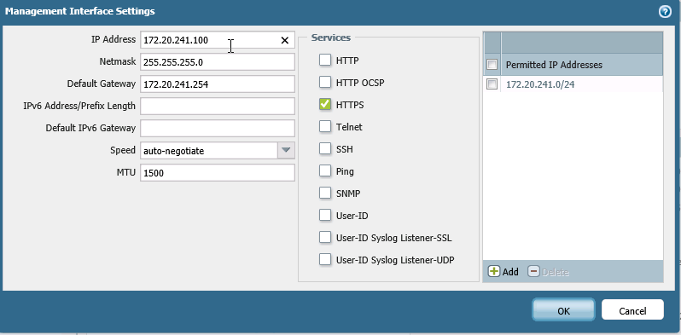

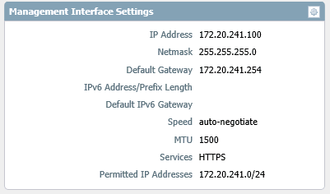

The firewall administrator has also confirmed that SNMP has been disabled. The screenshot below confirms the setting on the firewall.

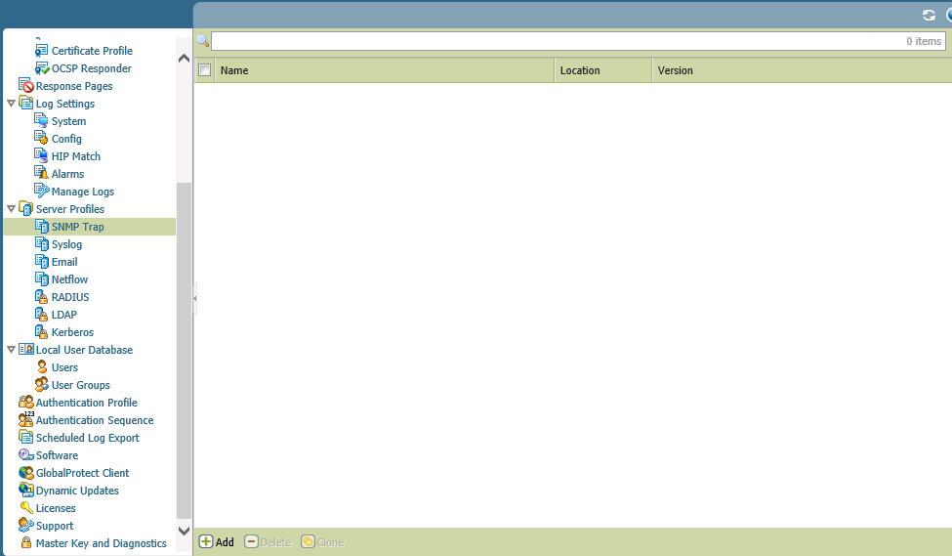

If there are any other concerns please let us know.

Respectfully,

Team 3